**PIZZA SALES SQL QUERY**

**KPLS**

1. **TOTAL REVENUE.**

select SUM(total_price) AS Total_Revenue

from pizza_sales

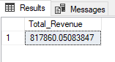

1. **AVERAGE ORDER VALUE.**

select SUM(total_price)/ COUNT(DISTINCT order_id) AS Avg_order_value

from pizza_sales.

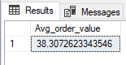

1. **TOTAL PIZZAS SOLD.**

select SUM(quantity) AS Total_pizzas_sold

from pizza_sales

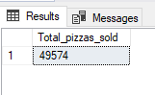

1. **TOTAL ORDER.**

select COUNT(DISTINCT order_id) AS Total_orders

from pizza_sales

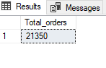

1. **AVERAGE PIZZAS PER ORDER.**

select SUM(quantity)/ COUNT(DISTINCT order_id) AS Avg_pizzas_per_order

from pizza_sales

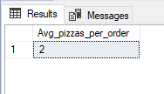

**CHART**

1. **DAILY TREND FOR TOTAL ORDERS.**

select DATENAME(DW,order_date) AS order_day, COUNT(DISTINCT order_id) total_orders

from pizza_sales

GROUP BY DATENAME(DW,order_date)

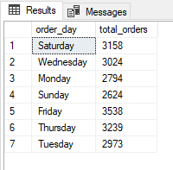

1. **HOURLY TREND.**

select DATEPART(HOUR,order_time) AS order_hour, COUNT(DISTINCT order_id) total_orders

from pizza_sales

GROUP BY DATEPART(HOUR,order_time)

ORDER BY DATEPART(HOUR,order_time)

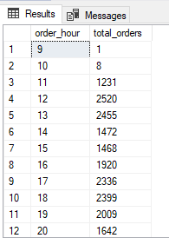

1. **PERCENTAGE OF SALE BY PIZZA CATEGORY.**

select pizza_category, SUM(total_price) * 100/(select SUM(total_price) from pizza_sales)AS Percentage_of_sales

from pizza_sales

GROUP BY pizza_category

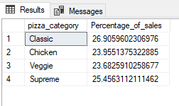

1. **PERCENTAGE OF SALES BY PIZZA SIZE.**

select pizza_size, SUM(total_price) * 100/(select SUM(total_price) from pizza_sales)AS Percentage_of_sales

from pizza_sales

GROUP BY pizza_size

ORDER BY Percentage_of_sales DESC

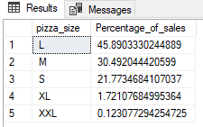

1. **TOTAL NUMBER OF PIZZAS SOLD BY CATEGORY.**

select pizza_category, SUM(quantity) AS total_pizza_sold

from pizza_sales

GROUP BY pizza_category

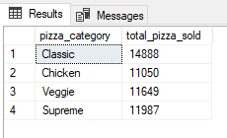

1. **TOP 5 BEST SELLERS BY TOTAL PIZZAS SOLD.**

select TOP 5 pizza_name, SUM(quantity) AS total_pizza_sold

from pizza_sales

GROUP BY pizza_name

ORDER BY total_pizza_sold DESC

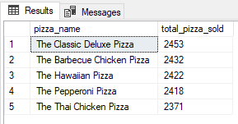

1. **BOTTOM 5 BEST SELLERS BY TOTAL PIZZAS SOLD.**

select TOP 5 pizza_name, SUM(quantity) AS total_pizza_sold

from pizza_sales

GROUP BY pizza_name

ORDER BY total_pizza_sold ASC

